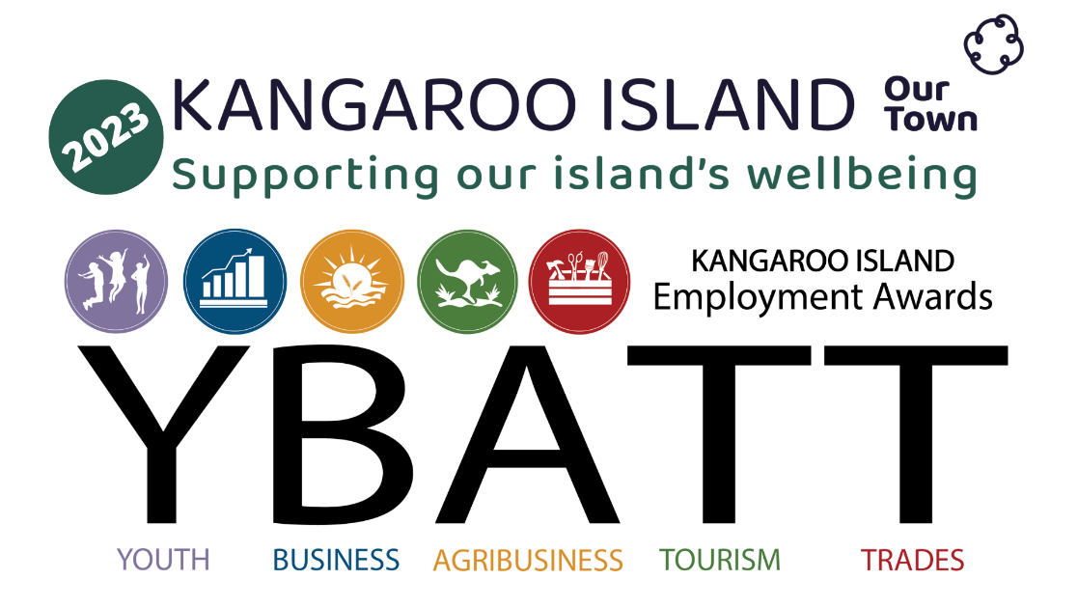

**Nomination Application**

**Family Friendly Business Award**

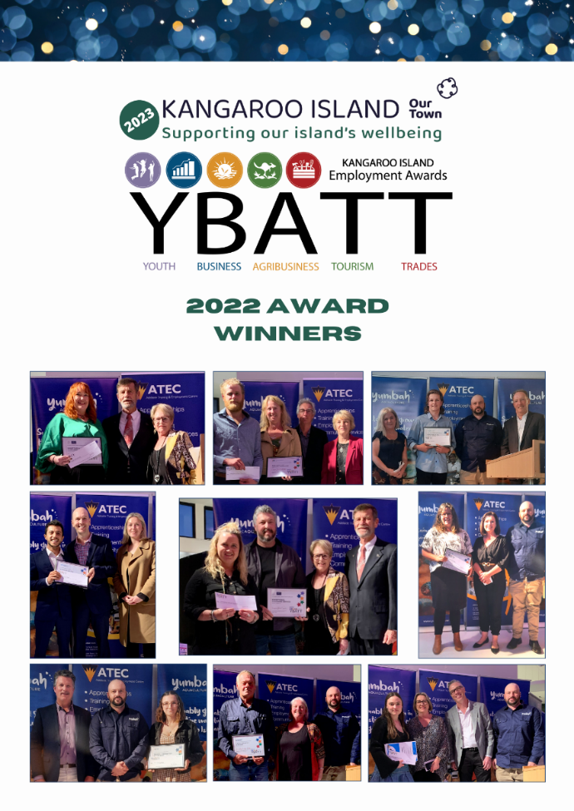

# Application Criteria

To be successful in gaining an award, the application must respond to the following criteria:

**Criteria 1: Business Planning**

* Does the Employer have a current Business Plan in place?

**Criteria 2: Recruitment and Skills Development**

* Is there a recruitment and training policy in place?

**Criteria 3: Leadership**

* Demonstrated leadership attributes towards employee and in the broader community.

**Criteria 4: Additional Benefits**

* Does the employer go above and beyond legislative requirements?

**Criteria 5: Award Specific Criteria**

* Respond to the specific criteria for the relevant award category.

|  |  |
| --- | --- |
| **EMPLOYER DETAILS** | |
| Business Name |  |
| Contact |  |
| Phone Number |  |
| E-mail Address |  |
| Size: | ◻ Micro Business  ◻ Small Business - 2-5 Full time Employees (or equivalent FTEs)  ◻ Medium Business - 6-15 Full time Employees (or equivalent FTEs)  ◻ Large Business - 16+ Full time Employees (or equivalent FTEs) |
| Years in operation: | ◻ Business started in 2023  ◻ 5-10 years  ◻ 11-20 years  ◻ 20+ years |
| Details of any current training being delivered by business  *(identify here if an apprenticeship or traineeship is being undertaken or just completed)* |  |

|  |
| --- |
| **Criteria 1: Business Planning** |
| 1. Provide a general overview of the business, including a brief history and summary of current operations. |
|  |
| 1. Describe the products and/or services. What makes the business unique and sets it apart from competitors? |
|  |
| 1. Describe the business’s target market. |
|  |
| 1. Describe how the business plan supports the wellbeing of the team? |
|  |

|  |
| --- |
| **Criteria 2: Recruitment and skills development** |
| 1. Does the employer engage a unique process to recruit, retain, and motivate staff? Please describe. |
|  |
| 1. How has the employer demonstrated their commitment to development and maintenance of skills of themselves (if sole trader) or their employees? |
|  |
| 1. In what ways do recruitment and training practises focus on the mental health and wellbeing of the team? |
|  |
| **Criteria 3: Leadership** |
| 1. How has the employer demonstrated positive leadership attributes towards their employees? |
|  |
| 1. How has the employer demonstrated positive leadership attributes towards their community? |
|  |
| 1. How has this demonstration of leadership positively affected the business? |
|  |
| 1. How does the nominee’s leadership style create a positive and healthy work environment? |
|  |

|  |  |
| --- | --- |
| **Criteria 4: Additional Benefits** | |
| 1. Does the employer provide any additional benefits above and beyond legislative requirements? | |
|  | |
| 1. What additional benefits for the wellbeing of the team are in place? | |
|  | |
| **Criteria 5: Specific Questions** |
| Please provide additional details as outlined below: |
| 1. Facilities: Describe the equipment that you have available to improve the experience of parents, grandparents and/or guardians of young children.   *(e.g. change tables that are regularly cleaned; a quiet area for breastfeeding if requested; a supply of tissues and wipes; baby products to purchase (such as dummies, bibs); clean & sanitised high chairs; does your venue have adequate accessibility and space for prams & strollers.* |
|  |
| 1. Children’s meals: Do you offer healthy options for children? Are there additional things that you do? *(e.g. brightly decorated children’s menus; can your kitchen accommodate any dietary requirements; do you provide freebies or low cost options like baby cinos, plain biscuits; do you serve children first; provide them with colourful placemats, children’s cutlery, plastic cups with lids.)* |
|  |
| 1. Children’s entertainment: Do you provide activities for children?   *(e.g. colouring books and crayons; board games to occupy kids at the table; have a play area like a sandpit or indoor play gym.)* |
|  |
| 1. Your employees: Does your business have policies to support working primary carers? Are these policies verbal or written?   *(e.g. flexible hours around schooling and childcare arrangements; accommodate breastfeeding mothers; paid maternity/paternity leave; job sharing; childcare facilities.* |
|  |
| 1. Staff awareness: Do you offer training to ensure that your staff are aware of your family friendly policies? Describe your policies and procedures and provide evidence of how they are implemented. *(e.g. do you educate and train your staff on how to have family-friendly attitudes and adopt procedures to promote better guest experiences for families; a welcoming attitude towards breastfeeding; do you encourage your staff to come up with unique ideas for children?* |
|  |

|  |
| --- |
| **Final Comments**  Please provide any additional information you would like to support your nomination. |
|  |

# Certification

|  |  |
| --- | --- |
| I certify that the information included in this application is to the best of my knowledge true in all aspects, and that I have faithfully represented the nominee. | |
| Name |  |
| Signature |  |
| Date |  |

# Publicity

|  |  |  |  |
| --- | --- | --- | --- |
| **Image and bio**  Please attach a high-quality image of the nominee. Below, please add a few words that would be suitable to include in a social media post (25 words or less). | | | |
|  | | | |
| **Radio Interview** | | | |
| Would the nominee like to be interviewed by 5kixFM Community Radio? | | Yes  ◻ | No  ◻ |
| If yes, please provide best contact details: | | | |
|  | | | |
| **Acknowledgement**  The below signed business or employee approves the use of their image and the brief profile on social media. | | | |
| Name |  | | |
| Signature |  | | |
| Date |  | | |

**Please forward your completed confidential application form:**

Via the **Submit** option on the KIBBA Website

OR

Drop In: Kangaroo Island Business Hub, Commercial St,

Kingscote (next door to Drakes supermarket), marked “CONFIDENTIAL”