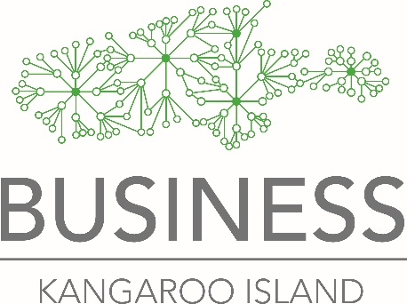
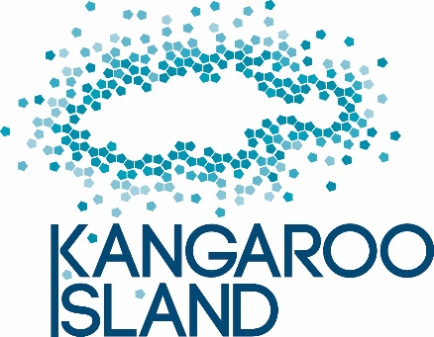

Amalgamation of KIIBA and BKI
Kangaroo Island Industry and Brand Alliance – Business Kangaroo Island

Why are we amalgamating?
At the AGMs of both associations last year, members agreed to explore an amalgamation that would make the new association stronger and more sustainable.
A working group made up of three members of each association’s committee/board has been working on a new Constitution, as well as a membership model, finances, name, website and so on. This work is still under way as this update is provided to you.
What are the benefits of amalgamation?
It means we can pool our financial and human resources so we can do more and do it more efficiently. For example, the new association is predicted to have about 164 members - a stronger voice to Government. Also it will stop us duplicating each other’s roles, for example, in sending out multiple newsletters and information, and paying for separate accounting subscriptions and insurance.
Members at the two recent AGMs have agreed that there are too many industry associations on Kangaroo Island and that a rationalization such as this will make things less confusing for members and for the industries and governments we speak to on behalf of our members.
What about the Brand?
The “Authentic Kangaroo Island” Brand will become part of the new association but not everyone has to sign up to use the trademarks. There will be a tiered membership structure with different prices and different member obligations and benefits attached to each.
What will the new association be called?
After much discussion, the working group has agreed on Kangaroo Island Business and Brand Alliance – KIBBA.
What about the website?
Both websites will be incorporated under the established www.authentickangarooisland.com.au domain name. An online business directory has been part of BKI’s business plan and will be incorporated on this website as a member benefit for the new association. The new association will also adopt the corporate “Kangaroo Island” branding to reflect its diverse membership.

The new Board
The new Board will comprise four nominees from each of the current board/committee of BKI and KIIBA and allow for three appointed members (to be appointed by the new Board). The new Board will elect its own chair from within.
How much will membership cost?
The new association must become financially sustainable and it must be able to do things to benefit its members. It is not enough to rely on volunteers.
The fee structure will change, with your new fees being implemented in the 2019-20 financial year, based on your expiry date.
For members who currently belong to both BKI and KIIBA (Level 1), the membership fee will stay the same. Some members will see a fee increase of $50 and a very few larger businesses will see an increase of $100.
We are working hard to maximise member benefits of this new, streamlined organization.
Business membership $100
Brand membership Level 1 $250 ≤ 5 FTE employees
Brand membership Level 2 $550 6-20 FTE employees
Brand membership Level 3 $1100 >20 FTE employees

What happens next?
You will soon receive a Notice of Special General Meeting for Monday May 20, and a new draft Constitution for KIBBA. The notice will include a Special Resolution on which members can vote at the Special General Meeting.
If that resolution is approved, you will receive more information about the mechanisms of amalgamation as we move to the new association on July 1.
We welcome your feedback. Please contact info@authentickangarooisland.com.au.

